SHERIFFHALES PARISH COUNCIL
Including the communities of Sheriffhales, Lilyhurst, Burlington, Crackley Bank, Heath Hill, Weston Heath, Redhill, Chadwell and Lilleshall Hall.

Clerk to the Council: 34 Brackendale Way, Stourbridge, DY9 7HG
Telephone: 07419204836. Email: clerk@sheriffhalesparishcouncil.uk
Website: www.sheriffhalesparishcouncil.uk

SPECIFICATION AND INVITE FOR TENDER FOR:

Footpath – to reinstate a path from Church Lane to the Church gates on Church Lane, Sheriifhales and removal of tree T2

The material specification required is attached to this tender a product called Cellweb® TRP Tree Root Protection system.

Details of the tree to be removed and the pathway are detailed below:-

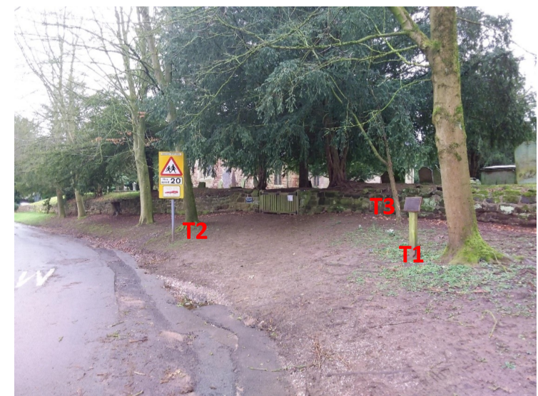

Given the relatively poor form and potential structural weakness of T2 it is not recommended that this tree is retained if the footpath is constructed. If the tree is retained the proposed footpath will come very close to its base, with the edge of the path likely to be situated no more than 30 – 40cm from the buttress. It does not seem reasonable to have to implement the protection measures that will be necessary to minimize root damage when the tree is not suitable for long term retention. The Tree should be removed entirely from site.

As the site is situated within the Sheriffhales Conservation Area, six weeks prior notice will need to be given for the removal of T2. Shropshire Council’s Tree Team can submit this notification on behalf of Highways upon request. The Parish Council have applied for this.

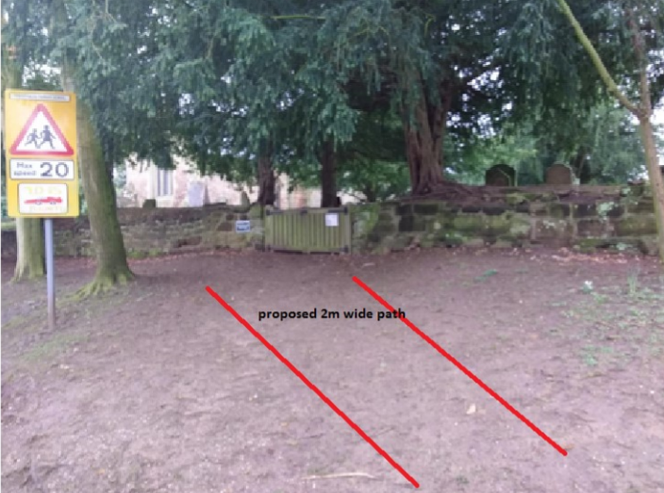

The path will be constructed using a no dig method, to avoid damaging any tree roots.

This will involve laying a cellular confinement system on the soil surface which is infilled with an MOT type 1 stone and a geotextile membrane laid beneath it to prevent the fill material penetrating the soil. An overlay of gravel or tarmac is applied to give the finished surface. Timber board can be used for edging. There are various proprietary cellular systems available, the leading brand is called Cellweb.

A copy of this product information is attached in the email being sent with this report.

A no dig method will create a path which is raised above the existing ground level. The amount it is raised will depend upon the depth of the cellular system which is installed but as the path will only be used by a small number of pedestrians on a limited basis it could be constructed using the minimum depth of the product which is 75mm. A wearing course/finished surface of at least 50mm will take the raised path to 125mm.

The advantages of this type of construction apart from the obvious one of avoiding any root damage is that the path will have good drainage, the finished surface does not have to be tarmac, other materials such as gravel could be used and the path is less likely to be damaged by future root growth. It is though likely to be more expensive than a conventional path.

All spoil to be removed from site.

TENDERS TO BE RETURNED to Parish Clerk by 31st 2020 in a sealed envelope with the envelope clearly labelled path tender

