**MINUTES OF THE SHERIFFHALES PARISH COUNCIL MEETING HELD ON THE 10th JANUARY 2019 AT SHERIFFHALES VILLAGE HALL**

Present: Councillors: Dr Alan MacWhannell (Chairman); Mr John Horne; Mr Gordon Tonkinson; Mr Nicholas Edwards; Mr Kevin Turley; Mr James Bubb and Mr Stewart Edmondson.

In attendance Clerk to the Council – Miss Jennifer Cree

The Chairman opened the meeting at 19.30 and thanked Councillors for their attendance. The Chairman reminded Councillors that this wherever possible papers should have been read before attendance at the meeting and it was good practice for meetings to not extend beyond 2 hours at any one sitting.

1/19. Apologies for Absence.

Apologies of absence were received from Councillor Pulker due to his being on annual leave.

2/19. Public Participation – a maximum of 15 minutes for members of the public to address the Council.

The public participation is for the public to address the Parish Council on matters that they wish to raise. The Parish Council cannot comment or resolve action on any points raised at this time. If the item requires information being sent from the Council, the Clerk will do this following the meeting. If it is a matter for further discussion it may be added to a future agenda.

There were no members of the public present.

3/19. Declaration of Councillors’ Pecuniary Interests.

None were declared.

4/19. To receive and agree the Minutes of the Parish Council meeting held on 8th November 2018.

The Minutes of the meeting held on 8th November 2018, having been circulated in advance of the current meeting, were approved and signed as a true record of the proceedings.

5/19. To note and where necessary agree responses or actions requiredrelating to Planning Applications and Decisions received since last Council Meeting.

18/05408/FUL, Woodcote Quarry, Weston Heath, Shropshire. Retention of 50 tonne low level horizontal silo, 70 kva generator jet wash, water and diesel storage tanks

18/05490/FUL, Woodcote Quarry, Weston Heath, Shropshire. Application under section 73a of the Town and Country Planning Act 1990 for the erection of maintenance workshop building.

As both applications relate to the same site, it was agreed to send the following recommendation: -

The generators for use at the Jet wash site should be restricted to hours of use, so to ensure noise is not an issue.

We understand that the buildings may be already in situ but we query whether the lighting on the site is as the approved plans as it is extremely bright and can be seen from great distances from the development causing light nuisance. The lighting of the site should confirm to previous Planning conditions.

On the previous planning applications for the site, part of the planning consent was that all traffic related access works were to be completed before the site was to be used. This issue (as previously raised with planning) should be confirmed before any further applications are approved and all aspects of the section 106 should be completed and if not enforced by Shropshire Council.

18/05732/FUL Grange Acre, Weston Heath, Shifnal

Erection of customer facilities and tea room building and storage following demolition of existing, ancillary to existing plant business.

No objection.

**Decisions made**

18/033 18/05786/FUL The Farmhouse, Ferndale Farm, Lodge Road, Donnington Erection of 2 storey single and side extension - Planning permission granted, this was noted.

**Enforcement**

18/06351/ENF Woodcote Quarry, Weston Heath, Shropshire

Alleged breach of planning condition 12a attached permission 17/03661/EIA, this was noted.

6/19. To receive a report on Progress in updating and relaunch of Website and related Communication Strategy and agree further steps.

Councillor Edmondson reported on Progress on the Councils Communication strategy and outlined the new Policy previously circulated (appendix 1). Members thanked Councillor Edmondson for his work. The Clerk reported that the Website itself remained complex to update and after discussion it was agreed that it be replaced with a simpler platform that the Clerk would lead on.

7/19. To receive a report on progress with Environmental Maintenance Grant application and agree any further actions required.

It was reported that the year 2018 application had been submitted and that funding would cover the period from award, now expected mid-January, to end March 2019 with funds awarded, if any, having to be spent or returned by the end of that period. Assessment of bids would be made against new criteria which included restriction to work to Shropshire Council land only. Work would also require match funding of at least 50% by the Parish. It was agreed to discuss the next years grant at the February 2019 meeting. It was noted that the Parish Council should not be taking over Shropshire Council duties.

8/19. To receive a status report on the Playing Field Community Space including Play Area and agree next actions and objectives now the boundary has been surveyed and Arboriculture report completed.

The Clerk and Chairman are meeting with the surveyor to clarify the boundaries that are now established marked and electronically recorded and to agree the more accurate plan for submission as required. The Arboricultural report on trees around the site had not identified any trees requiring immediate attention and identified only one tree that needed major attention.

9/19. To receive, if available, the results of the Audit of Road Improvements in the Centre of Village from Shropshire Highways and any other Road safety Concerns (including parking and congestion) within the Parish.

Councillor Turley reported that the report has been finalised and a copy should have been received prior to the meeting but had not been made available to him. The report as soon as received and actions arising from it will be an agenda item for the next meeting.

It was noted that Kettlemore Lane and Great Chatwell Lane are both showing significant deterioration and in parts, arevery badly damaged. The previously repaired roadway at the Junction of Church Lane and the Evergreens has deteriorated rapidly is unsatisfactory.

With respect to other Environmental maintenance works required or previously discussed it was noted that the formal complaint relating to the delayed response to requested actions to improve visibility at the A5 / Burlington Ford junction had been submitted and a response should have been received by the 31st December 2018. The Clerk has reported she is still awaiting a response and Shropshire Council have not responded according to their formal complaint procedure.

10/19. To note correspondence received related to Housing Needs Assessment and Neighbourhood Plan Proposal and agree next steps if required.

The Council was informed that the Housing Needs Survey is scheduled to start in mid-February initially with a mailing to all residents but also with public consultation using other Parish media platforms and opportunities to engage. The Clerk has received positive responses and offers of assistance from neighbouring Parishes and no objections to the boundary published as part of our Neighbourhood Plan Boundary submission.

11/19. To receive an Update on Casual Vacancy.

The Clerk informed the Council that an election was not called for the vacancy and no candidates had come forward for co-option by Wednesday 2nd January. The seat will remain vacant until a suitable candidate is found. There has been expression of interest from a member of the community who was on holiday at the time of the meeting. The Chairman will speak to them when they return from their holiday.

12/19. To discuss relocation of Clerk to office within Parish for trial period to evaluate if this will improve community engagement and communication and agree next steps.

It was agreed that for a period of 2 months trial period the Clerk would be at times located in the Parish to support engagement with the community. The costs were expected to be minimal but would support consultation at a local level. This to be advertised on the village notice-boards and in the Parish magazine.

13/19. To agree the Insurance Renewal

The Insurance renewal has come through from Came and Company for £398, it was agreed to proceed with this cover for this year due to the renewal date being in 2 weeks, but next year will go out for competitive tender.

14/19. To agree a policy for the noticeboards.

The Chairman of the Council reported that he had prepared a policy and distributed it to all members prior to the meeting. This document is set out as appendix 3 to these minutes.

It was agreed to discuss the policy further at the next meeting and also consider options relating a separate business noticeboard at the next meeting.

15/19. To agree the accounts up to 31/10/2018 and ratify / agree accounts for Payment.

The Accounts are set out as appendix 2 to these minutes. It was agreed to discuss reserve funds for future projects and their priority at the next meeting.

The ratification list is detailed below:-

|  |  |  |
| --- | --- | --- |
| **ACCOUNTS FOR RATIFICATION** | | |
|  |  |  |
| Chq No | Amount | Supplier |
|  |  |  |
| 1247 | £87.00 | INLAND REVENUE |
| 1248 | £348.59 | J CREE |
| 1249 | £90.00 | M EDWARDS |
| 1250 | £30.00 | SHERIFFHALES PCC |
| 1251 | £557.60 | MADLEYS |
| 1252 | £500.00 | PCC / SCHOOL |
| 1253 | £0.00 | CANCELLED |
| 1254 | £399.00 | LAPTOP |
| 1255 | £360.00 | GRASS CUTTING |
| 1256 | £16.00 | RBL wreaths |
| 1257 | £87.20 | INLAND REVENUE |
| 1258 | £348.39 | J CREE |
|  |  |  |
|  | £2,823.78 |  |

These were noted.

16/19. Items for future Meetings: schedule to be decided

Christmas Lighting Display 2019

Remembrance Day 2019

Civic Service 2019

Scope for Parish wide events 2019

Accounts for reserved projects

Noticeboard policy

Communication policy

Highway deterioration

Refuse collection and Litter Picking

17/19. Dates of Next Meetings

7th February 2019

14th March 2019

16th May 2019

11th July 2019

12th September 2019

7th November 2019

Appendix 1 to the minutes of Sheriffhales Parish Council held on the 10th January 2019

**DRAFT (v1.1)**

**SHERIFFHALES PARISH COUNCIL - COMMUNICATIONS AND MEDIA POLICY**

**Introduction**

This policy sets out the Sheriffhales Parish Council approach and procedures for its external communications. It is important that our communications policy contribute to the achievement of the overall objectives of the Parish Council. Communications is fundamental to achieving the Council’s overall mission. The purpose is to formalise the commitment of the Council to maintaining effective communications with all stakeholders, including and the Press and Public.

This policy sets out the principles of communications that underpin the Council’s approach, along with the key elements of our communications policy: audience, message and channels. The policy includes separate Annexes covering Media and Public Consultations.

**Aim**

Through good communication, we will understand and better meet the needs of the community, whilst also raising the profile of Sheriffhales and the work of Parish Council.

**Purpose**

The purpose of this policy is to ensure the Parish Council has effective communications in order to: help us achieve our overall organisational objectives, engage effectively with stakeholders, demonstrate the success of our work and ensure people understand what we do. In particular, good communications will enable the Council to:

* better understand the needs of the community and develop appropriate strategies and priorities
* raise residents’ satisfaction, trust and confidence by communicating about services provided by the Council.
* make best use of technology to innovate and engage with harder-to-reach groups of residents.

**Audience. Who should we be communicating with?**

The Council’s audiences include:

* Residents (including hard to reach groups such as young people).
* Voluntary groups and organizations (such the RBL, Village Hall Committee and WI).
* The Primary School.
* Shropshire Councillors and officers/staff.
* The media.
* The business community (and those that work in the Parish).
* Local MP.
* Other public sector organisations (police, health, fire).

**Message. What should we be communicating?**

External communications are designed to support the objectives of the Council. The parish councils form the bottom tier of Local Government. The role of Sheriffhales Parish Council is to:

* allow communities to have a say in how some of their local affairs are conducted.
* liaise with higher tiers of government.

All communication from the Council should be courteous, timely, professional, appropriate and reflects the decisions and policies of the council.

**Channels. How should we be communicating?**

The council will ensure that information is easily accessible, relevant and timely and recognises the importance of communication and commits to meet the expectations of the community it serves.

Different forms of communication will appeal to different ages, social groups and demographics so it is important to ensure that within reason, all options for increasing communication and participation are considered in order to communicate effectively with everyone. There are two methods of communicating:

* Proactive – telling people information to influence and change attitudes.
* Reactive – giving residents information they have requested

The advances made in information technology offer new ways of communicating. However, at the same time for many people, traditional methods – newsletters, telephone and notices – still play a fundamental role that must not be undervalued.

Currently, we use the following communications channels:

* Council’s Website.
* The Parish Council Notice Board.
* Articles in the Parish Magazine.
* Social Media (Twitter).
* Council agenda papers/correspondence.
* Annual Parish Meeting.
* Councillor interaction.
* Issue specific consultation.

**Evaluation. Are our communications effective?**

It is important that the Council measure the effectiveness of its communications. The Council will measure and consider:

* Levels of awareness about the Parish Council and the services it provides
* Attitudes of all stakeholders towards Sheriffhales Parish Council.
* Participation and engagement with Council projects, initiatives and consultation processes.
* Increased attendance at meeting and events.

How will we do this?

* Consultation with residents – perception and satisfaction surveys.
* Monitor press coverage.
* Visits to the Website.
* Number of interaction and Followers on social media.

Annexes:

1. Communications with the Media.
2. Public Consultations.

Annex A.

**Communications with the Media.**

The media plays an important role in shaping perceptions of local government, so informed reporting is vital. The Communities and Local Government report found people were most positive about their council in areas where the council had a good relationship with the local media.

All communication to the media by councillors in their Sheriffhales Parish Council role must be sent to the Parish Clerk or the Chairman of the Council for approval.

Key points for effective management of media relations:

* Respond to journalists in full within a reasonable time
* Be helpful, polite and positive
* Never say “no comment”
* Ensure all statements or responses to hostile enquiries are cleared by the Parish Clerk or the Chairman
* Evaluate media coverage
* Issue timely and relevant press releases
* Pre-empt potential stories arising from council agendas/minutes by issuing proactive PR (where possible)
* Ensure all media contact is with the Parish Clerk or Chairman (or in their absence, the Vice Chairman) as per Standing Orders.

Annex B.

**Public Consultation.**

At present, most of the Council’s consultation is by way of occasional questionnaires on specific subjects and members interaction with the public.

The Council will establish means by which consultations will take place to cover all aspects of life in Rawdon so that a full understanding of the needs of the community is developed. An action plan and council priorities can then be developed, which will be reviewed annually. The in-depth consultation will be repeated every five years. This will help to ensure that the council is engaged, delivering relevant services and truly representing the needs of the community to other authorities/partners. The information obtained will also help to provide useful evidence in support of initiatives and funding bids.

In addition, regular (annual) consultation should be undertaken by councillors to gather public opinion on perception and satisfaction of the council and the work it does. The results of this consultation would also help to better understand the council’s strengths and weaknesses and would help the council to measure the effectiveness of its work in general and this strategy specifically.

The consultations need to be developed in such a way that there is an opportunity for all members of the community to engage in the process. Therefore, an analysis of the format of this consultation needs to be undertaken including:

* **Who** – develop an understanding of the demographics of the community and
* **How** - establish ways of communicating with each of these that best encourages their engagement in the process
* **What** – consider what information is required and develop relevant means of achieving this whilst still being appropriate, accessible and engaging
* **Where** – define the best locations for accessing and engaging with the different groups identified
* **When** – develop a timetable for the consultation process including when it is intended to hold consultation ‘events’

Once completed, strategies for delivering services and improvements where identified should be developed with annual consultations held to measure effectiveness of the council’s activities and reputation and a review of the in-depth consultation every five years.

Appendix 2 to the minutes of Sheriffhales Parish Council held on the 10th January 2019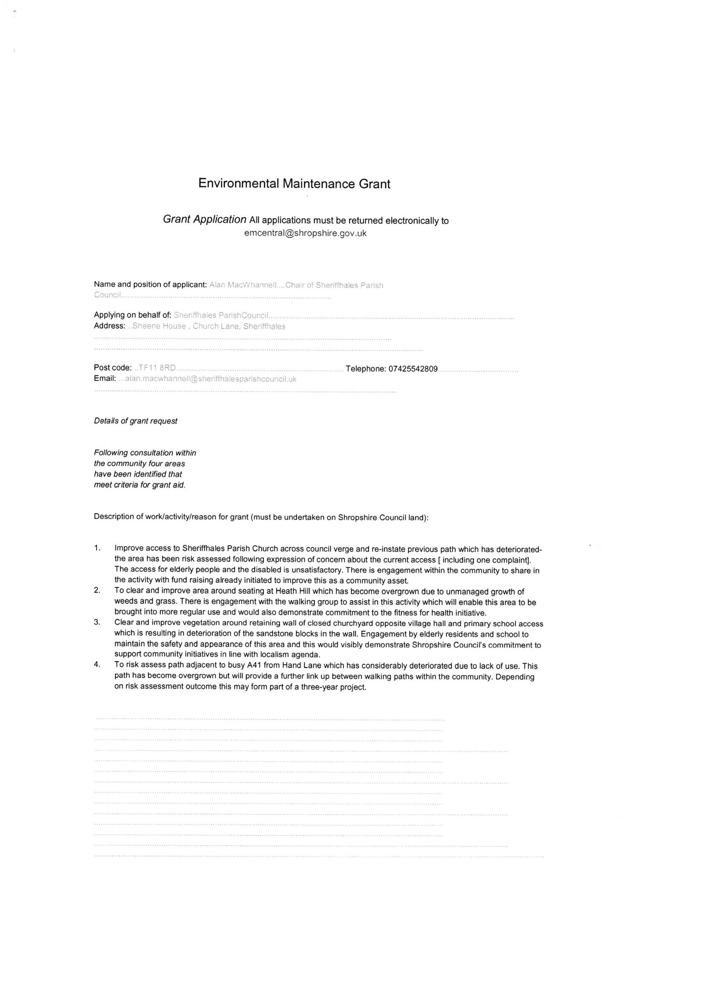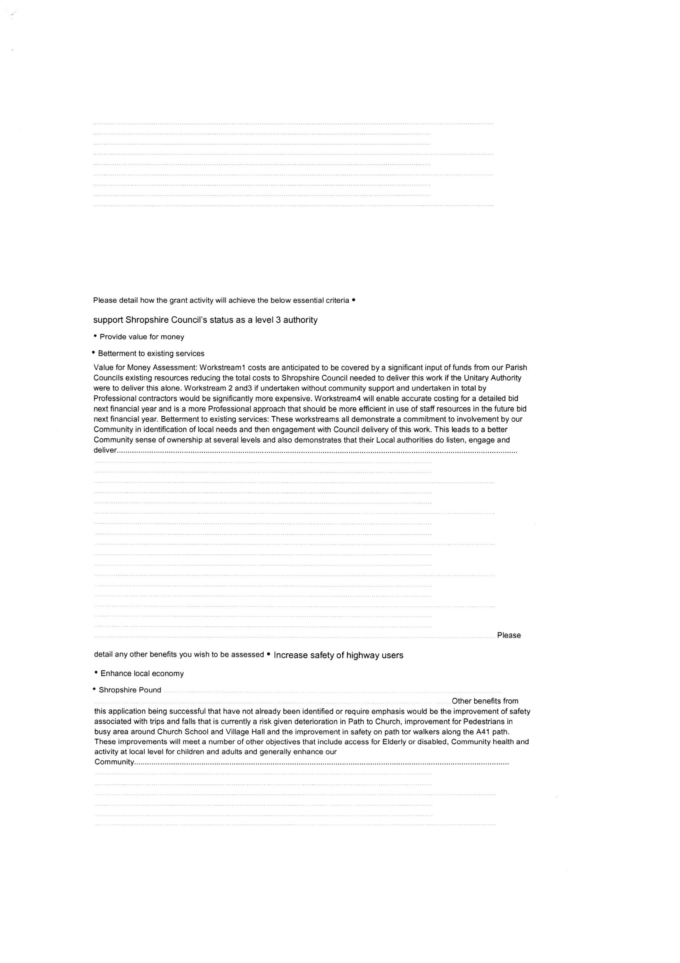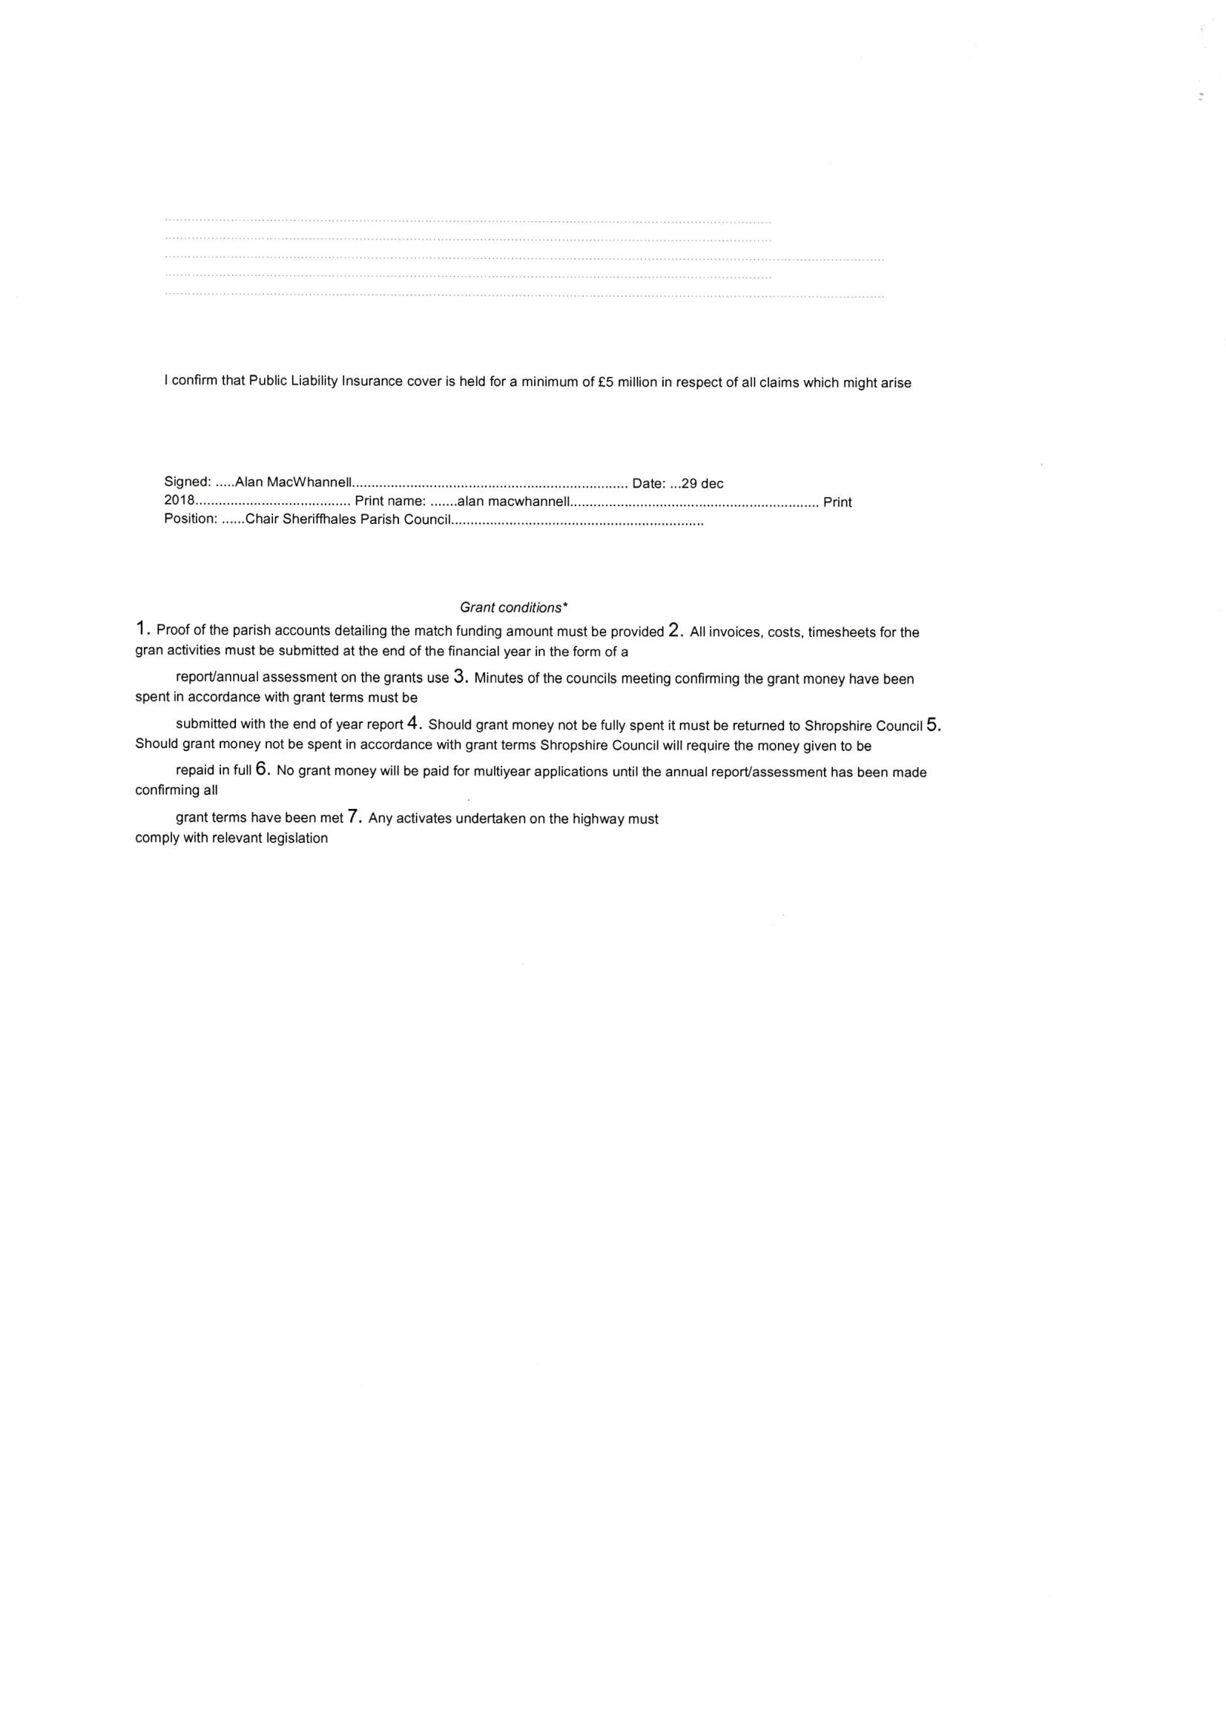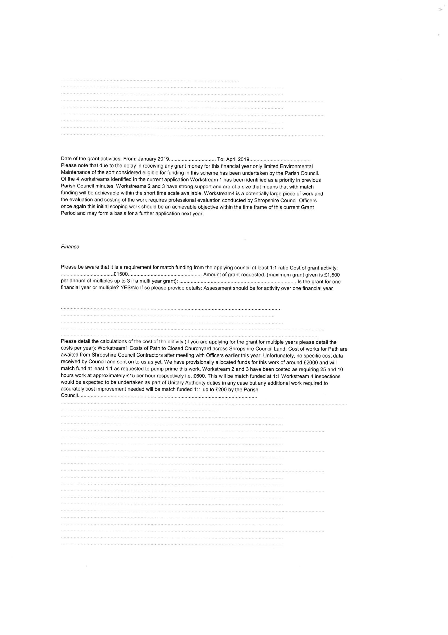

Appendix 3 to the minutes of Sheriffhales Parish Council held on the 10th January 2019

**Sheriffhales Parish Council Noticeboard Policy Introduction** This policy describes the proper use and maintenance of Sheriffhales Parish Council noticeboards.

**Background** Parish Councils are required to maintain a noticeboard for statutory notices to be published and other notices to be displayed. Notices displayed on a Parish noticeboard are for planning purposes advertisements as defined in section 336(1) of the town and country planning act 1990(as amended). This policy outlines the proper use and maintenance of noticeboards in the Parish.

**Location of Parish Noticeboards;** Physical noticeboards in Sheriffhales Parish are located at the top of Church Lane adjacent to the Layby. A smaller noticeboard is also located adjacent to the entrance to the cemetery at the bottom of The Rock. Official notices must by law be displayed on at least one of the physical noticeboards. Notices may also be published on the Parish Website.

**Use of Parish noticeboards** Parish boards may be used for official notices, statutory notices and community information notices.

**Official notices** Official notices include but are not limited to: Parish Council agenda. Parish Council minutes. Election notices and results Statutory notices relating to the Annual Audit. Notices advertising the Annual Parish Meeting. Notices advertising Parish Council Meeting dates. Contact details of Parish Clerk.

**Community information notices** Community information notices include but are not limited to: Notices from and for organisations and residents of Sheriffhales Parish. Notices from organisations outside the parish but being of interest to residents.

**The following are not normally to be displayed on the physical noticeboards:** Commercial advertisements. Publicity for any fundraising event or organisation that is not a charity. Political notices.

**Requirements to be met by advertisers** Notices should contain information on the date of posting and the date the notice should be taken down. If not clear from the notice the name and contact details of the author should be added to the notice. Notices should be factually correct and must not be critical or offensive to any person or organisation.  
**Authority to use noticeboards and related matters** The Parish Clerk has the authority to display notices on the noticeboards. Community information notices will be displayed provided space is available however Official Notices will always take precedence. Counsellors can also advise on suitability of notices and receive material for publication from residents where necessary. Material should ideally be sent to the Clerk as a Hard Copy.

**Display of material on Parish Council website.** In addition to physical noticeboards the Parish Council has a website which is also used to display Parish Council agendas minutes and meeting dates, detail of Financial Regulations, Codes of Conduct, other Policies and links to other Websites. Material for posting on the Parish Council website should be sent in electronic format to the clerk in the first instance but is subject to a separate policy. **Fly posting** No material is to be displayed on the physical noticeboards without prior knowledge of the clerk and unauthorised notices or notices which are fly posted on public property around the Parish e.g. lampposts will be subject to removal by the council.

**Policy version 1.0, January 2019, Author Alan MacWhannell Policy review date February 2020**

Appendix 4 to the minutes of Sheriffhales Parish Council held on the 10th January 2019

|  |  |  |  |  |  |  |
| --- | --- | --- | --- | --- | --- | --- |
| **SHERIFFHALES PARISH COUNCIL** | | | | | | |
|  |  |  |  |  |  |  |
| **BANK RECONCILIATION** | | | | | | |
|  |  | **2018/19** |  |  |  |  |
|  |  |  |  |  | **Date** | 31/10/2018 |
|  |  |  |  |  |  |  |
| **Accounts** |  |  | £ |  | £ |  |
| Opening Balance Treasurer as at 01/04/18 | |  |  |  | 52,446.64 |  |
| Business account |  |  |  |  | 3,541.72 |  |
| Unpresented cheques |  |  |  |  | - 2,280.29 |  |
|  |  |  |  |  | **53,708.07** |  |
|  |  |  |  |  |  |  |
| Receipts 2018/9 |  |  | 17,691.29 |  |  |  |
| Payments 2018/19 |  |  | 7,982.99 |  |  |  |
|  |  |  |  |  | 9,708.30 |  |
|  |  |  |  |  | **63,416.37** |  |
|  |  |  |  |  |  |  |
| Treasurers Account |  |  |  |  | 60,449.86 |  |
| Business Account |  |  |  |  | 3,542.77 |  |
| Unpresented cheques |  |  |  |  | - 576.26 |  |
| Unpresented receipts |  |  |  |  | - |  |
|  |  |  |  |  | **63,416.37** |  |
|  |  |  |  |  |  |  |
|  |  |  |  |  |  |  |
|  |  |  |  |  |  |  |
|  |  |  |  |  |  |  |
| Balance date: | 01/11/2018 |  |  |  |  |  |
|  |  |  |  |  |  |  |
|  |  |  |  |  |  |  |
| Signed:......................................................................Date:............................................... | | | | |  |  |
| Chairman |  |  |  |  |  |  |
|  |  |  |  |  |  |  |
| Prepared by J Cree, Parish Clerk/RFO | |  |  |  |  |  |
|  |  |  |  |  |  |  |
|  |  |  |  |  |  |  |
| **Unpresented cheques** |  |  |  |  |  |  |
| uncleared | 1216 | £30.00 |  |  |  |  |
| uncleared | * | £11.06 |  |  |  |  |
|  | 1244 | £400.00 |  |  |  |  |
|  | 1245 | £35.20 |  |  |  |  |
|  | 1246 | £100.00 |  |  |  |  |
|  |  |  |  |  |  |  |
|  |  |  |  |  |  |  |
|  |  |  |  |  |  |  |
|  |  |  |  |  |  |  |
|  |  |  |  |  |  |  |
|  |  | **£576.26** | **£0.00** |  |  |  |

|  |  |  |
| --- | --- | --- |
| **Date** | **Amount  £** | **Item** |
| 27/04/2018 | 15,000.00 | precept |
| 27/04/2018 | 2690.24 | county funding |
| 09/04/2018 | 0.15 | Lloyds interest |
| 09/05/2018 | 0.15 | Lloyds interest |
| 11/06/2018 | 0.16 | Lloyds interest |
| 09/07/2018 | 0.14 | Lloyds interest |
| 09/08/2018 | 0.15 | Lloyds interest |
| 09/09/2018 | 0.16 | Lloyds interest |
| 09/10/2018 | 0.14 | Lloyds interest |
|  |  |  |
|  |  |  |
|  |  |  |
|  | **17,691.29** |  |

|  |  |  |  |
| --- | --- | --- | --- |
| **Date** | **Chq  No** | **Amount** | **Description** |
| 19/04/2018 | 1212 | 341.78 | J CREE |
| 19/04/2018 | 1213 | 85.40 | INLAND REVENUE |
|  | **April** | **427.18** |  |
| 20/05/2018 | 1214 | 355.46 | J CREE |
| 26/05/2018 | 1215 | 88.80 | INLAND REVENUE |
| 01/05/2018 | 1216 | 30.00 | PLAYING FIELDS |
| 15/05/2018 | 1217 | 0.00 | cancelled |
| 25/05/2018 | 1218 | 120.00 | Accountability |
| 01/06/2018 | DD | 98.24 | 1 AND 1 |
|  | **May** | **692.50** |  |
|  | **Total to date** | **1119.68** |  |
| 30/05/2018 | 1219 | 65.15 | J CREE |
| 14/06/2018 | 1220 | 348.39 | J CREE |
| 14/06/2018 | 1221 | 87.20 | INLAND REV |
|  | **June** | **500.74** |  |
|  | **Total to date** | **1620.42** |  |
| 06/07/2018 | 1222 | 100.00 | SHROPSHIRE COUNCIL |
| 06/07/2018 | 1223 | 96.60 | PLAYSAFE |
| 06/07/2018 | 1224 | 87.00 | INLAND REVENUE |
| 06/07/2018 | 1225 | 348.59 | J CREE |
| 19/07/2018 | 1226 | 120.00 | Angela Horne |
| 19/07/2018 | 1227 | 360.00 | Alan Harding |
| 19/07/2018 | 1228 | 258.75 | Village Hall |
| 19/07/2018 | 1229 | 607.50 | Village Hall |
|  | **July** | **1978.44** |  |
|  |  | **3598.86** |  |
| 31/07/2018 | **1230** | **348.39** | J Cree |
| 31/07/2018 | **1231** | **87.20** | Inland Revenue |
| 07/08/2018 | **1232** | **250.00** | Royal British Legion |
| 07/08/2018 | **1233** | **20.00** | Sheriffhales PCC |
|  | **DD** | **1618.91** | Public works loan |
|  | **August** | **2324.50** |  |
|  |  | **5923.36** |  |
| 13/09/2018 | **1234** | **348.59** | J Cree |
| 13/09/2018 | **1235** | **87.00** | Inland Revenue |
| 13/09/2018 | **1236** | **292.11** | SALC |
|  | **September** | **727.70** |  |
|  |  | **6651.06** |  |
| 17/10/2018 | **1237** | **0.00** | Cancelled |
| 17/10/2018 | **1238** | **87.20** | Inland Revenue |
| 17/10/2018 | **1239** | **121.14** | Archer Signs |
| 17/10/2018 | **1240** | **40.00** | ICO |
| 17/10/2018 | **1241** | **348.39** | J Cree |
| 17/10/2018 | **1242** | **200.00** | Royal British Legion |
| 17/10/2018 | **1243** | **0.00** | Came and Company |
| 26/10/2018 | **1244** | **400.00** | Sheriffhales Primary school |
| 26/10/2018 | **1245** | **35.20** | Bulbs |
| 26/10/2018 | **1246** | **100.00** | Sheriffhales Parish Magazine |
|  | **October** | **1331.93** |  |
|  |  | **7982.99** |  |
| 08/11/2018 | **1247** | **87.00** | INLAND REVENUE |
| 08/11/2018 | **1248** | **348.59** | J CREE |
| 03/11/2018 | **1249** | **90.00** | M EDWARDS |
| 08/11/2018 | **1250** | **30.00** | SHERIFFHALES PCC |
| 08/11/2018 | **1251** | **557.60** | MADLEYS |
| 08/11/2018 | **1252** | **500.00** | PCC / SCHOOL |
|  | **1253** | **0.00** | CANCELLED |
| 13/11/2018 | **1254** | **399.00** | LAPTOP |
| 19/11/2018 | **1255** | **360.00** | GRASS CUTTING |
| 19/11/2018 | **1256** | **16.00** | RBL wreaths |
|  | **November** | **2388.19** |  |
|  |  | **10371.18** |  |
| 31/12/2018 | **1257** | **87.20** |  |
|  | **1258** | **348.39** |  |
|  | **December** | **435.59** |  |
|  |  | **10806.77** |  |
|  | **1259** | **149.98** | Lights |
|  | **1260** | **397.97** | Came & Co |
|  | **1261** | **570.00** | Invor Mapping |
|  | **1262** | **87.20** | Inland Revenue |
|  | **1263** | **348.39** | J Cree |
|  | **January** | **1553.54** |  |
|  | **YTD** | **12360.31** |  |

