SHERIFFHALES PARISH COUNCIL
Including the communities of Sheriffhales, Lilyhurst, Burlington, Heath Hill,
Weston Heath, Redhill and Chadwell
Clerk to the Council: Miss Jennifer Cree, 35 Kingsford Park, Hobro Lane, Wolverley, DY11 5TA
Telephone: 07512292579. Email: clerk@sheriffhalesparishcouncil.uk
Website: www.sheriffhalesparishcouncil.uk

11th May 2021

TO ALL MEMBERS OF SHERIFFHALES PARISH COUNCIL, THE PRESS AND THE PUBLIC

Dear Sir or Madam

You are summoned to the Annual General Meeting of Sheriffhales Parish Council to be held at 7.00pm on Tuesday 18th May 2021, in Sheriffhales Village Hall

Yours faithfully
J S Cree

Clerk to the Council

AGENDA
48/21. Election of Chairman of the Parish Council for the Council Year 2021/22.
(the new Chairman to make his/her declaration of Acceptance of Office).

49/21. Appointment of Vice-Chairman of the Parish Council for the Council Year
2021/2.

50/21. Vote of Thanks to the Outgoing Chairman and Vice-Chairman.

51/21. Apologies for Absence.

52/21. Declaration of Councillors’ Pecuniary Interests.
.
53/21. To Agree and adopt the Minutes of the Parish Council meeting held on 11th March 2021.

54/21. Public participation for 15 mins to speak on matters relating to agenda items.

55/21. To Agree Parish Council signatories for Cheques and Internet Banking.

56/21. To Note and Agree existing Parish Council Standing Orders, Financial Risk Assessments and Financial Regulations.

57/21. To Note and Agree the Inventory of Parish Council assets including buildings and office equipment.

58/21. To Note and Agree Cover for all insured risks for the Parish Council.

59/21. To Note and Agree the Parish Council Complaints Procedure and Health and Safety policy.

60/21. To Note and Agree the Parish Council procedure for handling requests made under the Freedom of Information Act 2000 and the Data Protection Act 1998.

61/21. To Note and Agree the Parish Council Policy for dealing with the Press and media.

62/21. To Note and Agree that Councillors will submit to Shropshire Council as required information on Pecuniary interests and related matters by 10 June deadline

63/21. To Note and Agree the procedure for review of Planning Applications requiring a response before a next scheduled meeting.

64/21. To Note and Agree the Parish Council Grants Policy

65/21. To Agree a schedule of Parish Council meetings for the coming year.

66/21. To Agree that training needs of Staff and Councillors should be identified and, as per requirements of the Parish Council, met and delivered.

67/21. To Note that there were insufficient candidates to fill all existing seats on the Parish Council at the recent election and to Agree the process for advertising and filling the vacancies that have arisen by Co-option if no further election is called.

68/21. To ratify and Agree accounts for Payment.

69/21. To receive and Agree the year end accounts including Internal Auditors
Report for financial year 2020-21

70/21. Items for a future agenda

71/21. Date of Next Meeting

TBC

55/21. Agree authorisation of signatories for Cheques and internet banking
access.

The cheque signatories are Cllr A MacWhannell, Cllr J Horne, J S Cree, (former Cllrs Pulker and Edmondson)

To discuss internet banking.

57/21. To note inventory of land and assets including buildings and office equipment.

Total value of assets held by the Council on 31 March 2021
Date purchased Description Cost Total
£ £
Infrastructure 80,475
18/06/2004 Bus Shelter 5,475
28/03/2015 Sheriffhales Playing Field 75,000
Furniture/equipment 2,343
23/04/2013 Rainbow picnic bench 387
10/09/2013 Rainbow 3-seater bench 308
31/08/2011 Rubbish bin 500
20/09 & 15/11/07 Noticeboards 337
Chairman’s Chain 100
19/02/2016 Clerk Mobile 100
11/09/2019 Laptop 350
30/08/2016 Printer 199
Community 17,502
19/09/2013 2 Goal Posts 200
31/08/2011 Play equipment 15,302
08/02/2008 Small area of amenity land by road side. 2,000
Nov 2020 Benches / Noticeboard 3,791

58/21. To note insurance cover in respect of all insured risks for the Parish.
Insurance Cover is with Came and Company and is due for renewal on the 4th December 2021

65/21. To agree meeting schedule for the next year.

PROPOSED SCHEDULE OF MEETINGS FOR 2021/22

The meeting schedule has been drawn up based on the meeting scghedule in 2019, members may wish to discuss moving the meeting day to another evening.

 | Council meetings
MAY 2021 | 18 AGM
JULY 2021 | 15 APM and full council meeting
SEPT 2021 | 9
OCT 2021 | 14 (Budget)
DEC 2021 | 9
JAN 2022 | 13
MARCH 2022 | 10
APRIL 2022 | 14 APM
MAY 2022 | 12 AGM

67/21. To discuss filling the vacancies on the Parish Council following the elections (one person has put their name forward for consideration to date).

Former Councillor N Pulker has put his name forward for co-option.

68/21. To ratify and agree accounts for Payment.

01/04/2021 | 399.34 | 1473 | Admin
01/04/2021 | 180.00 | 1474 | neat n tidy
12/04/2021 | 147.23 | 1475 | j neal
01/04/2021 | 99.60 | 1471 | Inland rev
19/04/2021 | 127.99 | 1478 | Dittons
21/04/2021 | 100.00 | 1479 | Rutelle
Total April | 1054.16
01/05/2021 | 399.14 | 1476 | Admin
01/05/2021 | 99.80 | 1477 | Inland Rev

69/21. To receive and agree the year end accounts including Internal Auditors Report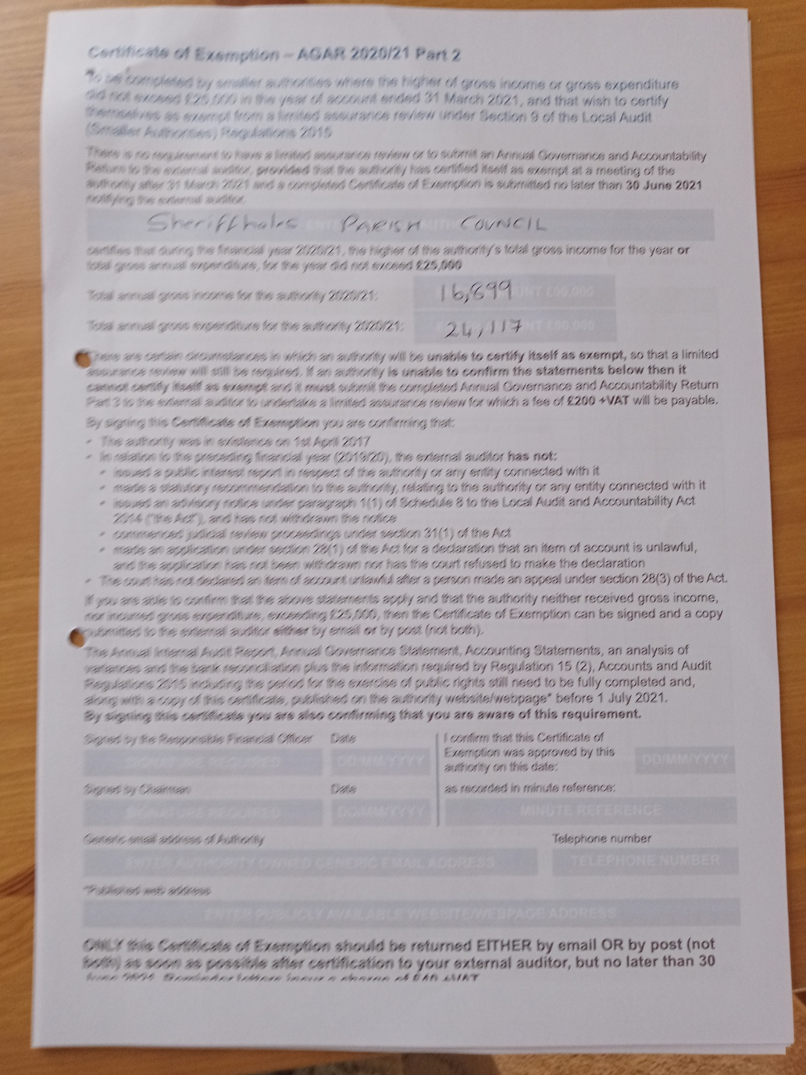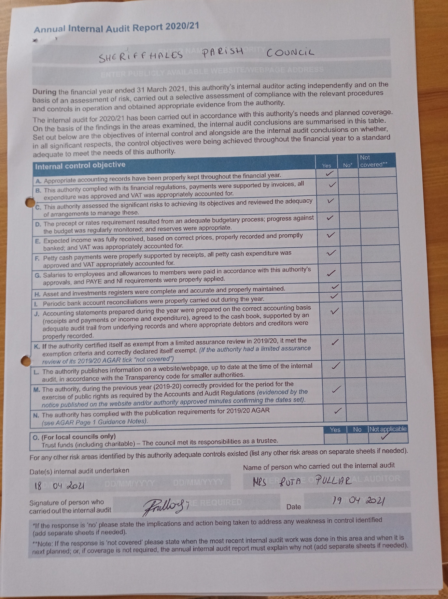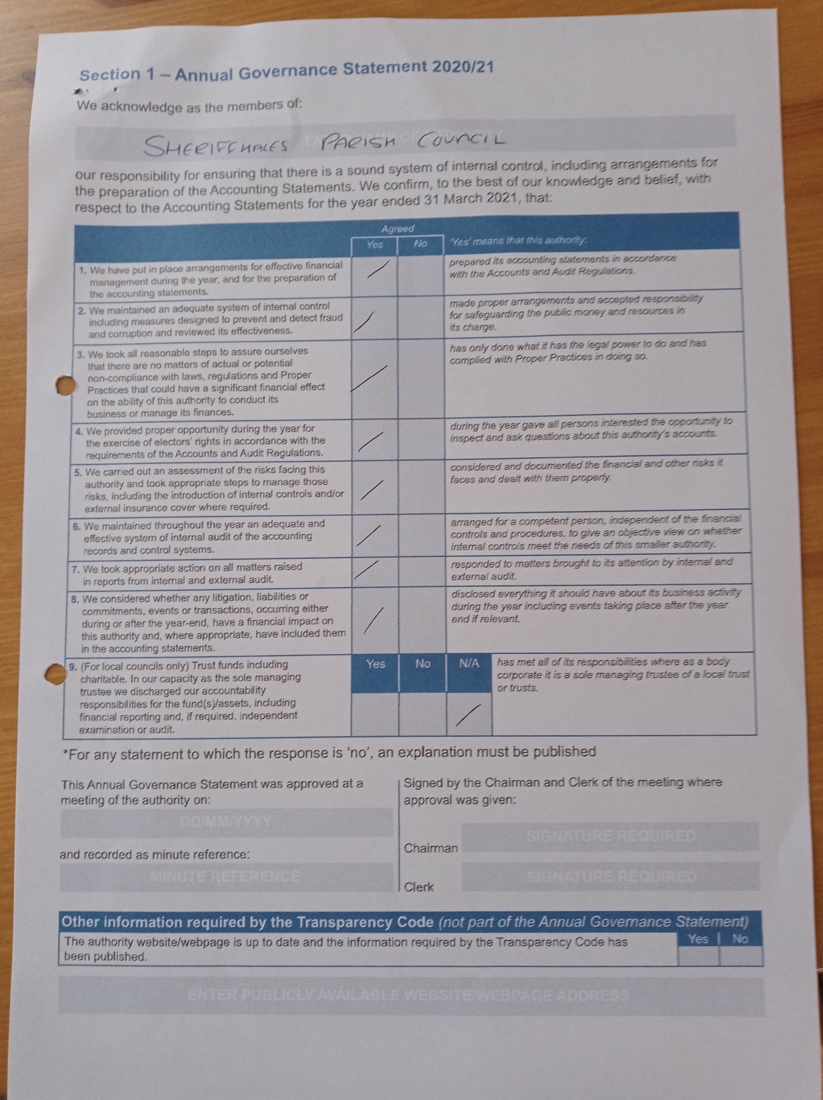

SHERIFFHALES PARISH COUNCIL
BANK RECONCILATION
 |  | 2020/21
 |  |  |  |  | Date | 31/03/2020
Accounts |  |  | £ |  | £
Opening Balance Treasurer as at 01/04/20 |  |  |  |  | 45,175.14
Business account |  |  |  |  | 3,545.31
Unpresented cheques |  |  |  |  | - 1,037.96
 |  |  |  |  | -
 |  |  |  |  | 47,682.49
Receipts 2020/21 |  |  | 16,898.96
Payments 2020/21 |  |  | 24,117.18
 |  |  |  |  | - 7,218.22
 |  |  |  |  | 40,464.27
Treasurers Account |  |  |  |  | 38,279.99
Business Account |  |  |  |  | 3,546.24
Unpresented cheques |  |  |  |  | - 1,361.96
Unpresented receipts |  |  |  |  | -
 |  |  |  |  | 40,464.27
Balance date: | 31/03/2021
Signed:......................................................................Date:...............................................
Chairman
Prepared by J Neal, Parish Clerk/RFO
Unpresented cheques
29/10/2020 | 500 | 1439
06/01/2021 | 255.98 | 1457
15/02/2021 | 127.99 | 1464
01/03/2021 | 350.00 | 1466
16/03/2021 | 127.99 | 1469
 | 1361.96

Budget Comparison 2020/21
Receipts | Budget | Actual | Balance
 | 2020/21 | Income | Remaining
Precept | £16,000.00 | £16,000.00 | £0.00
Highways Grant | £0.00 | £300.00 | £300.00
Transparency Grant | £0.00 | £0.00 | £0.00
Interest | £0.00 | £0.93 | £0.93
Total | £16,000.00 | £16,898.96 | £898.96
Payments | Budget | Actual | Balance
 | 2020/21 | received | Remaining
Salaries | £6,100.00 | £5,992.28 | £107.72
Stationery/postage/printing/exp./phone | £280.00 | £437.15 | -£157.15
Transport Expenses | £100.00 | £0.00 | £100.00
Parish Magazine this is S137 exp | £220.00 | £0.00 | £220.00
Events | £0.00 | £0.00 | £0.00
Adverts | £200.00 | £0.00 | £200.00
Audit | £400.00 | £100.00 | £300.00
Cllr/Clerks Training/conference | £500.00 | £60.00 | £440.00
Elections | £200.00 | £0.00 | £200.00
Subscriptions | £600.00 | £510.61 | £89.39
General Power of Competence | £90.00 | £0.00 | £90.00
Insurance | £420.00 | £449.89 | -£29.89
hire of venues | £250.00 | £225.00 | £25.00
Community Based Planning Prev. Parish Plan | £1,000.00 | £0.00 | £1,000.00
Civic / Community events | £1,000.00 | £0.00 | £1,000.00
Community Grants This is S137 expenditure | £1,000.00 | £0.00 | £1,000.00
Playing field maintenance | £1,500.00 | £1,405.87 | £94.13
Playing Field Loan | £3,240.00 | £3,237.82 | £2.18
Funding to deliver new prioritised programme fro EMG (match funding) | £2,000.00 | £1,426.25 | £573.75
Christmas Display | £0.00 | £80.00 | -£80.00
Specialist Services inc. Legal and professional advice | £1,000.00 | £1,100.00 | -£100.00
War Memorial / Remembrance | £0.00 | £77.00 | -£77.00
Website | £300.00 | £373.26 | -£73.26
Chairman's Discretionary exp. | £500.00 | £500.00 | £0.00
Footpath Maintenance | £0.00 | £0.00 | £0.00
Total Expenditure | £20,900.00 | £15,852.31 | £5,047.69
Total Income | £16,000.00 | £16,898.96 | -£898.96
Difference | £4,900.00 | £4,001.04 | £898.96
VAT to be reclaimed 31/3/21 |  | £1,754.37
Light Source Exp |  | £6,510.50
VAT Refund received 31/03/20 |  | £598.03

